**PART A**

Underline the most suitable answer. (2 marks x10 = 20 marks) 1. HTML is what type of Language?

a. Scripting Language

b. Markup Language

c. Network Protocol

d. Programming Language

2. Inside which HTML element do we put the JavaScript?

a. <script>

b. <javascript>

c. <js>

d. <scripting>

3. What is **NOT** a heading tag in HTML?

a. <h5>

b. <h3>

c. <h4>

d. <h7>

4. What is NOT a method of writing CSS?

a. Inline

b. External

c. Embedded

d. Attached

5. What does the <br> tag add to your webpage?

a. Long break

b. Paragraph break

c. Line break

d. None of above

6. Which of the following statements is FALSE for PHP

a. PHP is client-side scripting language

b. PHP scripts are executed on the server

c. PHP files can contain text, HTML, CSS, JavaScript, and PHP

d. PHP is a widely-used, open source scripting language

7. What is correct way to write a CSS color values?

a. p {background-color: black};

b. p {bg-color: black};

c. p {background-color: black;}

d. p <background-color>:{ black };

1

8. _________ keyword is used to declare variables in JavaScript.

a. var

b. dim

c. String

d. None of the above

9. When a user views a page containing a JavaScript program, which machine executes the script?

a. The user’s machine running a web browser.

b. The web server.

c. A central machine deep within Google’s corporate offices.

d. None of the above

10. What will be the output of the following PHP code

$num = 1;

$num1 = 2;

print $num . "+". $num1;

a. 3

b. 1+2

c. 1.+.2

d. Error

**PART B**

**Question 1 (Total – 20 Marks)** 1) Compare and contrast GET, POST requests. (You may use an example). 2) How to write comments in,

a) HTML

b) JavaScript

c) PHP

3) Write a JavaScript program to pops up prompt box.

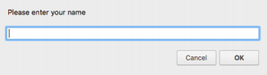

4) Write a JavaScript program to display the following.

*Sample Output:* I am a student of NSBM

2

**Question 2 (Total – 20 Marks)** 1) Write a PHP page to display “Hello Nsbm Green University!” in the page.

2) Explain the following diagram.

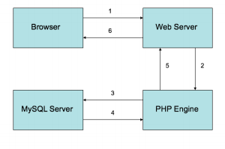

3) Write a PHP page to create the following page. And display the values in the same PHP page. 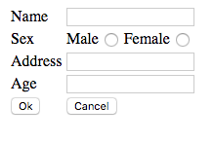

The table “**Items**” in the database “**Food_Items**” consists of the fields Item No, Description and Price. Assuming that the database and the table have already been created using MySQL, write a PHP page to insert the following record to the “Items” table.

| **Item No** | **Description** | **Price** |
| --- | --- | --- |
| D100 | Flour | 120.00 |

Use the SQL statement:

**INSERT INTO Items(`itemno`,`description`,`price`) VALUES (‘D100,'Flour',120);**

**<?php**

**$con=mysqli_connect("localhost","root","",”Food_items”);**

**if($con)**

**INSERT INTO Items(`itemno`,`description`,`price`) VALUES (‘D100,'Flour',120);**

**$res = mysqli_query($con**

**?>**

3

**Question 3 (Total – 20 Marks)** 1. What is the main role of CSS in Web Design (2 marks) 2. Briefly explain the difference between Classes and IDs used in CSS. (2 marks) 3. What is CSS box model? Define the use of its main elements (Margin, Border,

Padding, Content) (5 marks) 4. Create a simple HTML web page as follows (1 mark)

**Section 1 (**Header size = 1) 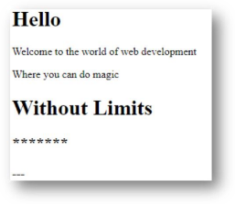

**Section 2 (**Paragraph)

**Section 3** (div)

**Section 4** Header size = 1

**Section 5** Header size = 2

**Section 6** Header size = 2

a. Write an external css file called style.css for the following requirements (4 marks)

i. Change the color of **section 2** to red.

ii. Change the color of **section 1** to red and align the text to center

using id selector.

iii. Change the color of **Section 5** and **Section 6** to green and align

the text to center.

iv. Change the color of **section 3** and **section 4** to blue using group

selectors to minimize the code.

b. Set the background color to “linen” for the page, using an internal style sheet. (1 mark)

c. Set the background color to “yellow” for the page, using an inline style. Assuming all the above code is available what is the background color

of the page now? (3 marks)

d. Use the CSS Box model to complete below tasks, (2 marks)

i. Set the width of **section 3** to 200px**.**

ii. Set the padding of the **section 3** to "25px".

iii. Set the border of the **section 3** to "25px solid black”

iv. Set the margin of the **section 3** to "25px".

4

**Question 4 (Total – 20 Marks)** 1. “Java Script is not a case sensitive language” is this statement true or false? Explain your answer. (3marks) 2. What is Document Object Model (DOM) in JavaScript? (3 marks) 3. Write a JavaScript program to calculate the area of a circle (radius=7) (4 marks)

4. Write a small JavaScript program to take three inputs (num1, num2, num3). Hint: Use prompt boxes to get inputs

(10 marks)

a. Add num1 and num2

b. Multiply the answer of above by num3

c. Use an alert box to display whether the final answer is an odd number or an even number.

*** End of paper***

5